Hey Apache Kafka,

What is Kafka?

* Kind of messaging system

What Solution Kafka Provides?

* Kafka uses distributed streaming for solving producer consumer problem.

Why to prefer Kafka over other Messaging systems?

* Kafka offers better solution for Consumer producer problem over other messaging managers like IBM MQ and Rabbit MQ, in simple java we use Blocking Queue(scope is limited to JVM instance) but these Messaging system can be applied to cluster of Data centers(scope is bigger)

Now let’s have a look at Kafka Architecture

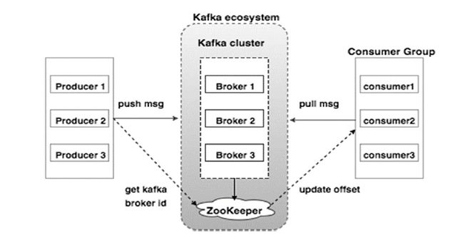

Zookeeper: - is used for service discovery across the brokers.

Brokers:- they are installed on different machines

Kafka:- it does distributed broker management using zookeeper(Discovery service)

In Kafka a message is added to the topic in partitions(or we can say a message is published in a topic having different partitions) and it can parallelly be consumed by consumers from different partitions.